PRO-FORMA OF APPLICATION
Application for the post of________________________________________________
Ref.Newspaper__________Advertisement No____________Dated___________
To
The Commander Junior Leaders Wing The Infantry School Belgaum-590 009 Karnataka
1. Full Name (In Block Letters)___________________________________
(As written in 10^{lh} / SSC Certificate)
2. Father's/Husband's Name (in Block Letters):_____________________
3. Date of Birth (as per the School Certificate):_____________________
4. Age as on last date of receipt of application i.e___Years__Months _ Days
5. Write category to which you belong (GEN/SC/ST)________________ (enclose certificate on prescribed format).
6. Whether ex-servicemen. If yes give details i.e length of service alongwith service Discharge Certificate__________
7. Whether Physically Handicapped (also indicate the type of disability)_______________
8. Nationality:______________
9. Religion_________________
10. Address and Pin code in full for communication with nearest Railway station______ Mobile No. (if any)______
11. Details of Academic / Technical & Professional Qualifications
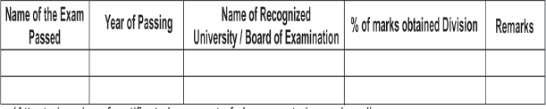
(Attested copies of certificate in support of above are to be enclosed)
12. Experience / if any (Please attach certificate):__________
13. Whether Govt. Servant, if yes. give details of post held, Pay scale and Date of entry in Govt Service._______
Declaration
I hereby declare that all the statements made in this application are true, complete and correct to the best of my knowledge and belief. In the event of any information being found false / incorrect or ineligibility being detected before or afterthe written test/skill test my candidature will stand automatically cancelled.
End: -1. One self - Attested Photographs with Name, Father's Name & Post applied For on the back side.
2. Postal Order No_________& Date______________for Rs 50/-
3. Attested copies of certificate ( ) sheets
Signature of the candidate
Name :-
Left Thumb Impression of Male candidate (Right thumb impression in case of female candidate)

